1. **Installing TMux, emacs, Fail2Ban, cowsay and lolcat**
2. To install Tmux we will use the command **sudo apt-get install tmux.** In my system it looks like it was already installed.
3. Text

   Description automatically generated
4. to install emacs we will be using the command **sudo add-apt-repository ppa:kelleyk/emacs** to update our repository list and add it to it.
5. Text

   Description automatically generated
6. Next run the command **sudo apt install** **emacs28.** We will install emacs28 since it is the latest release. Emacs is a text editor that allows you to edit or create new text files.
7. Next, we will install fail2ban by using the command **sudo apt install fail2ban**. Fail2ban is a tool that helps protect computers from brute force attacks by monitoring the services logs for malicious activities.
8. Text

   Description automatically generated
9. To install cowsay we will be using the command **sudo apt-get install -y cowsay**. Cowsay (or cowthink) will turn text into happy ASCII cows, with speech (or thought) balloons.
10. Text

    Description automatically generated
11. To install lolcat we will be using the command **sudo apt-get install -y lolcat**.
12. Text

    Description automatically generated
13. To get the latest versions of system programs before we install we run the command **sudo apt update.**
14. 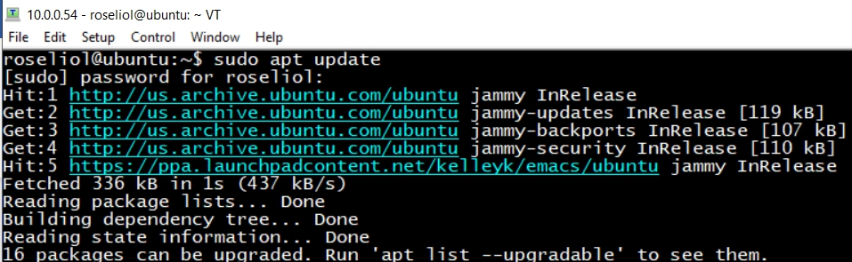
15. To see which packages, need to be updated we can use the command **apt list –upgradable**.
16. A picture containing graphical user interface

    Description automatically generated
17. To upgrade the packages, we run the command **sudo apt upgrade**. Which upgrade all of the packages seen in the previous picture. you might have to restart some services after the upgrade is done.
18. **Install VIM**
19. To install or update vim run the command **sudo apt-get install vim**. As you can see in the next picture, the version of vim installed in my system is already up to date.
20. Text

    Description automatically generated